Pilot Study of the Supervised Models on the Cleaned Diabetes Dataset

Seif ElAnsary†
CSCE Department
The American University in Cairo
ID:900221511
seif_elansary@aucegypt.edu
MagdElDin AbdalRaaof
CSCE Department
The American University in Cairo
ID: 900211145
MagdElDin@aucegypt.edu
MagdElDin AbdalRaaof
CSCE Department
The American University in Cairo
ID: 900211145
MagdElDin@aucegypt.edu

INTRODUCTION
This report will be a comparative analysis and discussion of the performance of all the supervised machine learning models we discussed in class. These models will be applied on our pre-processed, cleaned dataset from phase 2.
COMPARATIVE ANALYSIS

- Linear Regression

We used the standard Linear Regression class from sklearn. In order ensure the best model accuracy and avoid overfitting, we used 10-fold cross validation on the dataset. After that, we used the R2 as the performance metric for this model. After averaging out all folds, we arrive at the value R2 = 0.177. This is not that great of a value for a linear regression model; however, that is to be expected since our dataset has discrete labels rather than continuous ones, which makes this model not the best fit for our problem at hand.

- Logistic Regression

We used the standard Logistic Regression class from sklearn. 10-fold cross validation was also used to increase the reliability of the model and decrease overfitting. Unlike linear regression we used: Accuracy, Precision, Recall, F1 and AUC as the performance metrics for this model. After training and averaging, the final values were:
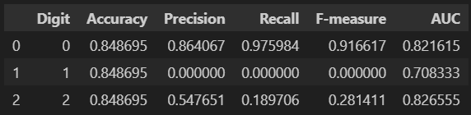
Figure 1
(0 represents non-diabetic, 1 is pre-diabetic and 2 is diabetic)
This model fits the data better than the linear regression model. But there are some problems in the model and the data in general. Due to the fact that the data has almost around 4x non-diabetics compared to diabetics, it will naturally be able to detect non diabetics more easily, since it has more data to train on. This is supported by the f1 values, since precision and recall are the performance metrics we should play close attention to in this dataset. F1(0) = 0.92 while F1(2) = 0.28. Hopefully, other more complex models can fix this disparity. Moreover, because of the very limited number of pre-diabetics in the dataset and how similar they are to diabetic people, it becomes impossible to identity them at all, as seen by their precision and recall values. This calls for the merging of them with diabetic patients.

- Multi-Layer Perceptron (ANN)

We used the MLPClassifier of sklearn having a hidden layer of 4x10, an input layer which have nodes equal to the number of features, 1 output node, a max iteration count of 1000, the relu activation function and the adam solver. The relu activation function scales well with positive features, making the neural network more robust. 1000 max iterations ensures that the weights converge and a 4x10 hidden layer should introduce complex non-linear behaviour between the inputs and outputs. 10-fold cross validation was also used to increase the reliability of the model and decrease overfitting. The performance metrics used were: Accuracy, Precision, Recall, F1 and AUC. The graphs ahead display the Precision, Recall and F1:
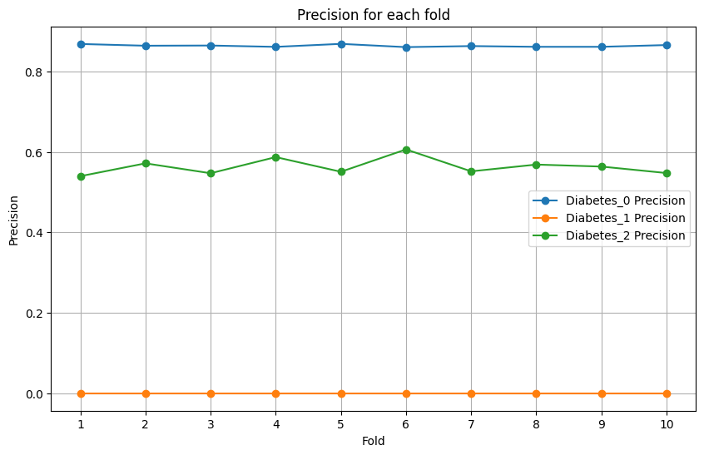
Figure 2

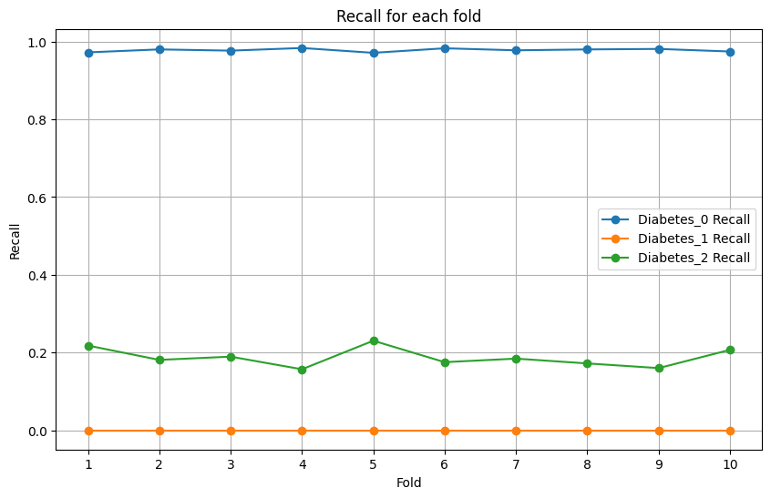
Figure 3

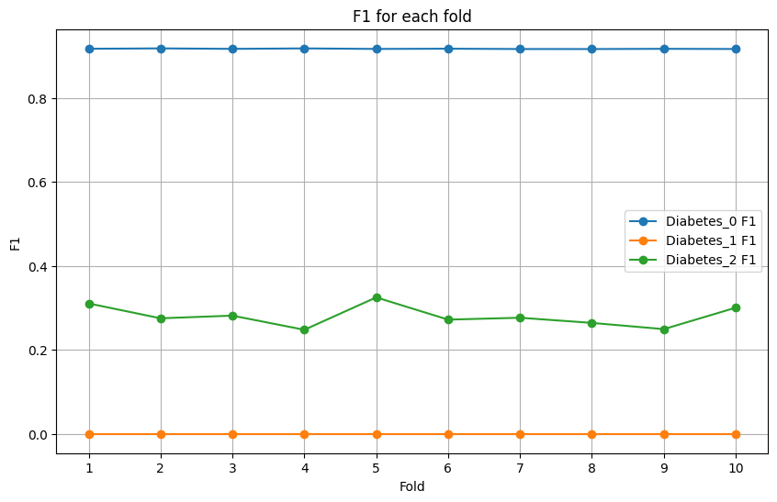
Figure 4

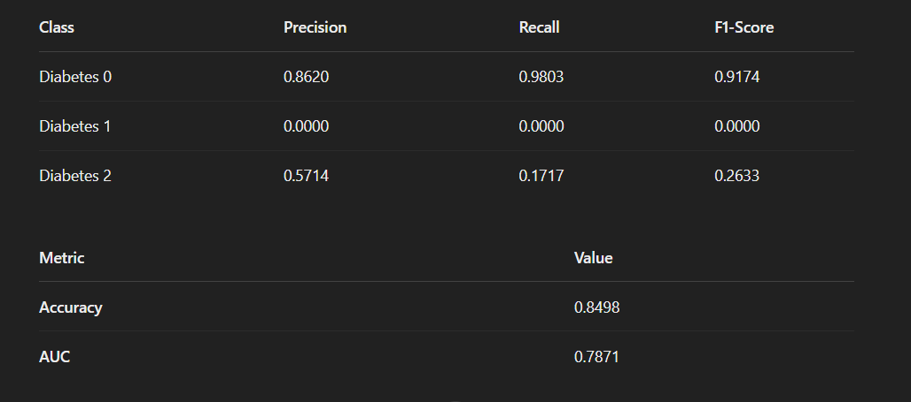
Figure 5

The MLP model has a very similar performance to that of the Logistic Regression one. This model also seems to value precision over recall in Diabetes 2. This indicates that this model is very careful when classifying if people are diabetic or not. However, this results in it missing a lot of positive diabetic cases. Prediabetic detection also still suffers from the same problem as being unidentifiable.

- Naïve Bayes

We used the Gaussian Naïve Bayes classifier from sklearn. 10-fold cross validation was also used to increase the reliability of the model and decrease overfitting. The performance metrics are the same as the Logistic Regression and MLP. The graphs ahead display the Precision, Recall and F1:

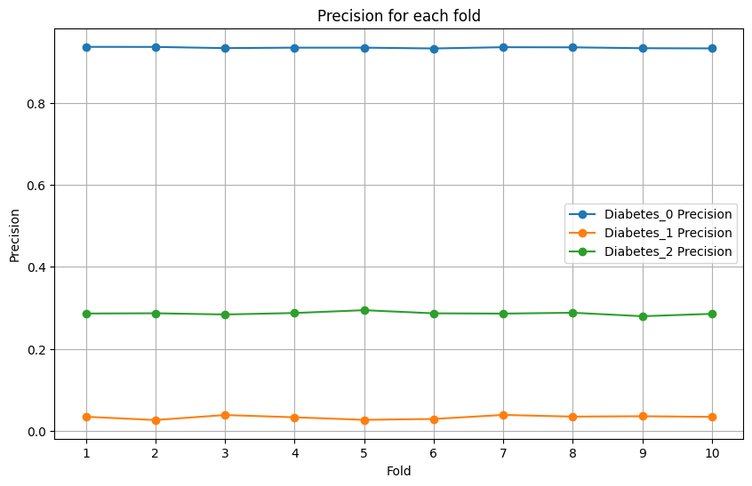
Figure 6

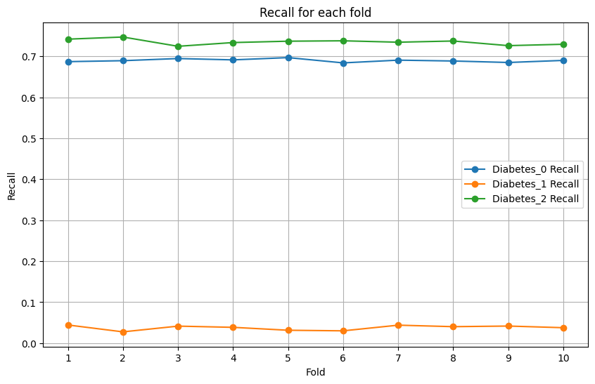
Figure 7

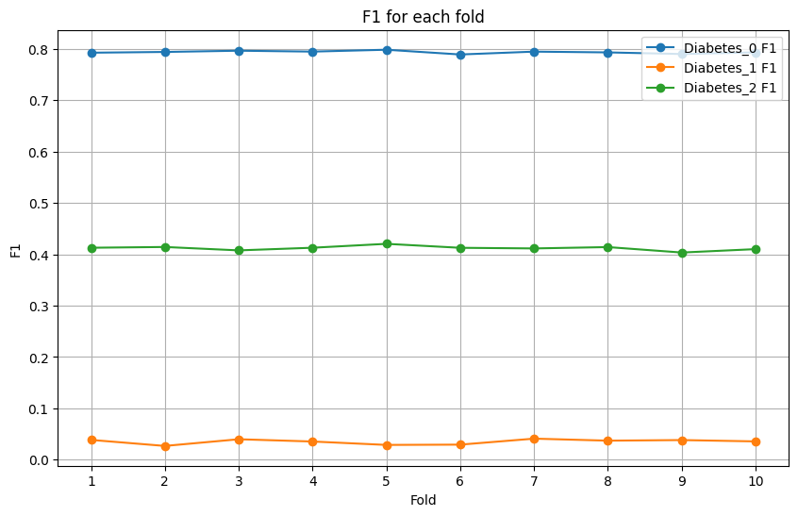
Figure 8

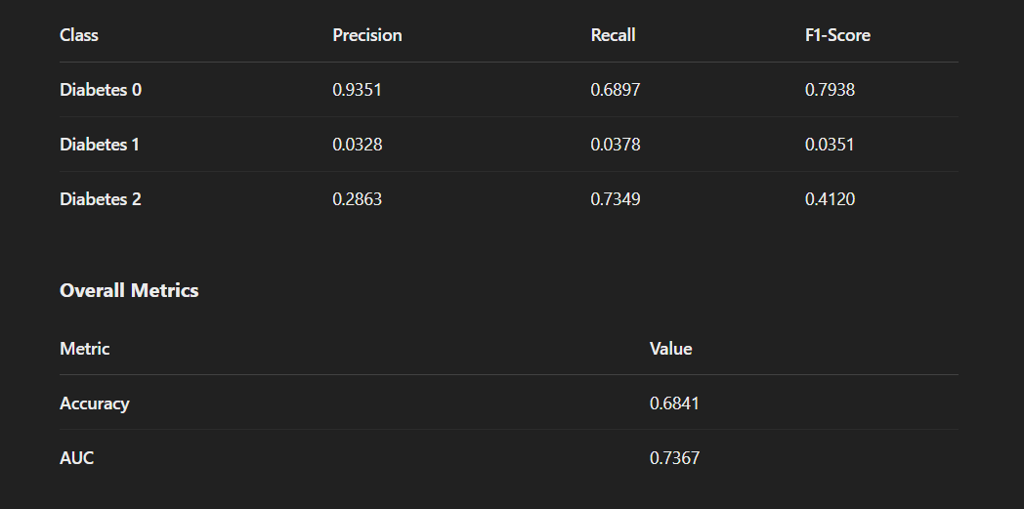
Figure 9

These metrics shown in Figure 9 show a new perspective. Here the model in Diabetes 2, unlike ANNs, had a much higher Recall value but a smaller Precision value. This indicates that this model is casting a wider net to catch more positive cases, but in return it is classifying a lot of negatives as positive, resulting in a lower precision rate. It seems that we have to find the balance between being too careful or being too careless when it comes to classifying if a person has diabetes. Moreover, The Recall of non-diabetics decreased a bit for this model. Maybe this is the result of the higher F1 score of the Diabetics.

- Decision Tree

We used the standard Decision Tree Classifier from sklearn. 10-fold cross validation was also used to increase the reliability of the model and decrease overfitting. Same performance metrics as before. The graphs ahead display the Precision, Recall and F1:

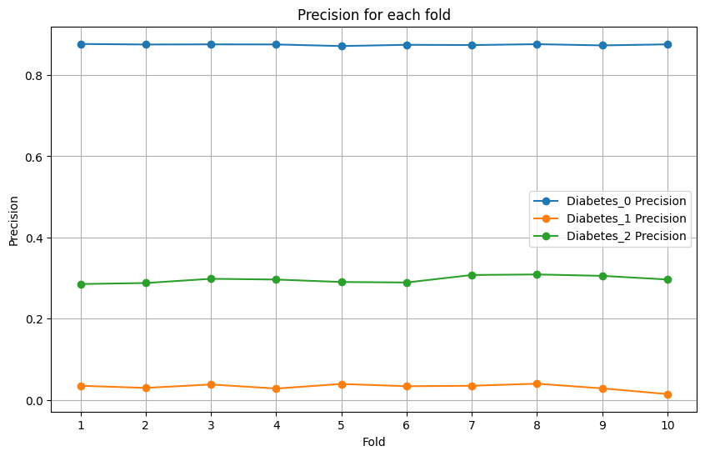
Figure 10

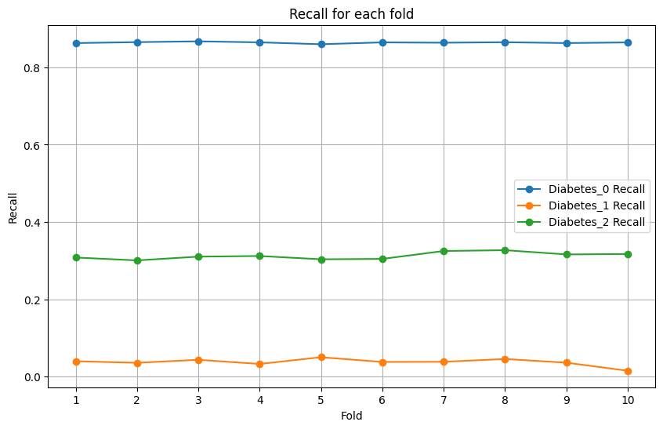
Figure 11

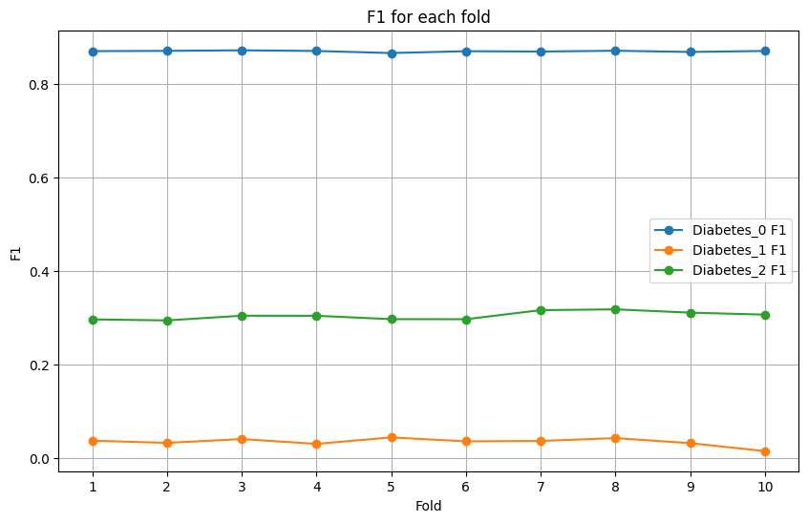
Figure 12

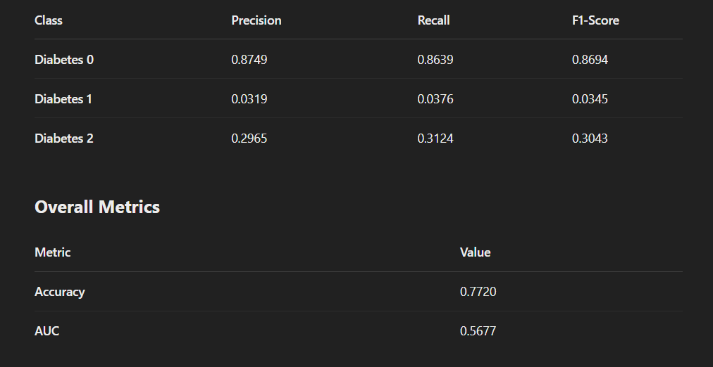
Figure 13

This model has a very similar performance to both the MLP model and the logistic regression model. One difference though is that for the Diabetic case, it has balanced Precision and Recall, but suffers from a lower Accuracy and AUC score. It is less accurate than other models.

- KNN

We use the KNeighborsClassifier from sklearn. 10-fold cross validation was also used to increase the reliability of the model and decrease overfitting. Same performance metrics as before. We tried 5 different values of N: square root number of rows, log number of rows, 243, 300 and 200. The results are:
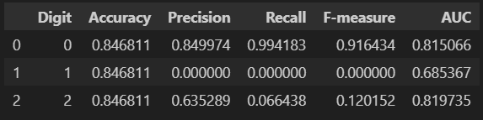
Figure 14(sqrt n)

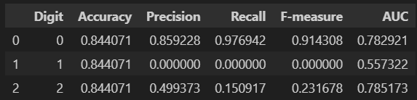
Figure 15(log n)

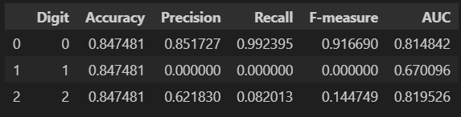
Figure 16(243)

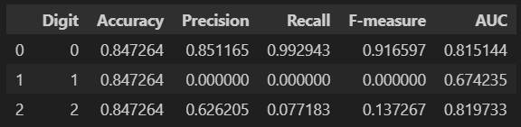
Figure 17(300)

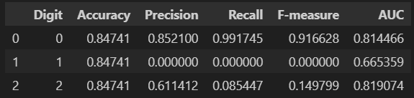
Figure 18(200)

This also seems like a model that is too cautious when classifying if a person has diabetes or not, corroborated by the 0.61 precision. The log model has the best F1 score out of them, but has also the worse average AUC.

